Que1) What is Computer Networks? Explain its types?

A computer network is an essential part of contemporary communication, which allows devices to share resources and information in an efficient manner. Different authors have given definitions of computer networks in their books, presenting different views based on technical, theoretical, and practical grounds. The following are four definitions by famous authors and their respective books:

1. William Stallings, Data and Computer Communications  
   "A computer network is an interconnection of a set of computing devices capable of communication and sharing resources."
2. James F. Kurose and Keith W. Ross, Computer Networking: A Top-Down Approach  
   "A computer network is a set of interconnected devices that communicate with each other to share data and resources."
3. Michael A. Gallo and William M. Hancock, Computer Communications and Networking Technologies  
   "A computer network is an interconnected collection of autonomous computers that can share information and resources."
4. F. Halsall, Data Communications, Computer Networks, and Open Systems  
   "A computer network is a collection of interconnected computing devices that can exchange data and share resources."

History of Computer Networks

Pre-1950s: The Era Before Computer Networks

Before computer networks existed, data processing was done manually or on isolated computers. Organizations relied on physical storage (such as punched cards and paper tapes) to transfer information, which was slow and inefficient. Communication between computers was non-existent, and data sharing required physical movement of storage devices.

1950s: Early Concepts of Networking

With the rise of mainframe computers, the need for efficient data sharing became evident. Large organizations used batch processing systems, where users submitted jobs to a central computer. The lack of direct communication between computers and remote access led to delays and inefficiencies in processing tasks.

1960s: The Birth of Computer Networks

1961: Leonard Kleinrock introduced the concept of packet switching, which became a fundamental idea for modern networking.

1965: The first computer-to-computer communication was established between two machines at MIT using a telephone line.

1969: ARPANET, the first real computer network, was created by the U.S. Department of Defence’s Advanced Research Projects Agency (ARPA). It connected four universities (UCLA, Stanford Research Institute, UCSB, and the University of Utah), proving that computers could communicate over long distances.

1970s: Expansion and Standardization

1973: The first international computer connection was made through ARPANET.

1974: Vinton Cerf and Robert Kahn developed the Transmission Control Protocol (TCP), laying the foundation for modern internet communication.

1978: TCP/IP was standardized, enabling different types of computers to communicate seamlessly.

1980s: The Rise of the Internet

1983: ARPANET switched to the TCP/IP protocol, marking the birth of the internet as we know it today.

1989: Tim Berners-Lee proposed the World Wide Web (WWW), revolutionizing how information was accessed and shared.

1990s-Present: The Age of Global Connectivity

1990s: The internet became publicly available, leading to rapid expansion and commercialization.

2000s: Wireless networks, mobile communication, and cloud computing transformed how people interacted online.

Today: High-speed internet, Fiber optics, 5G networks, and the Internet of Things (IoT) have made networking an integral part of daily life.

Challenges Before Computer Networks

Before computer networks were established, people faced numerous challenges, including:

1. Slow Data Transfer: Physical transportation of storage media (like floppy disks and punched cards) caused delays.
2. Limited Communication: Computers operated in isolation, making remote collaboration difficult.
3. Redundancy and Inefficiency: The same data had to be manually copied across different machines, leading to duplication and errors.
4. High Costs: Dedicated mainframe computers were expensive and required significant maintenance.
5. Security Risks: Without networks, sensitive information was stored physically, making it vulnerable to theft or damage.

Future Scope of Computer Networks

The evolution of computer networks continues to accelerate, driven by emerging technologies and increasing global connectivity demands. Key areas shaping the future of computer networks include:

1. Terahertz (THz) Communication: Operating in the 0.1-10 THz band, THz communication is expected to overcome current spectrum limitations, enabling unprecedented data transfer rates. Studies emphasize the need for new channel models and capacity analyses to harness this potential.
2. Reconfigurable Intelligent Surfaces (RIS): RIS technology involves surfaces that can dynamically control electromagnetic waves, enhancing signal strength and coverage. This innovation promises improved network performance and energy efficiency.
3. Internet of Space Things (IoST): The integration of CubeSats and terrestrial networks aims to provide seamless global connectivity, especially in remote areas. This development is poised to revolutionize data collection and communication.
4. Artificial Intelligence (AI) in Network Management: AI-driven networks can autonomously manage and optimize performance, leading to self-healing and adaptive systems. Research indicates that AI will play a pivotal role in future network infrastructures.
5. Ultra-High-Reliability (UHR) Wi-Fi: Wi-Fi 8, expected around 2028, aims to deliver speeds up to 100 Gbps, significantly enhancing wireless networking capabilities. This advancement will support data-intensive applications and reduce latency.
6. Information-Centric Networking (ICN): Shifting focus from host-based to content-based communication, ICN enhances data retrieval efficiency and security. Studies explore caching strategies and adaptive mechanisms within ICN frameworks.
7. Integration of Blockchain in Networking: Blockchain technology offers decentralized security solutions for network management, ensuring data integrity and trustworthiness. Research discusses the potential of blockchain in enhancing network security protocols.
8. Context-Aware Radio Access Technology (RAT) Selection: In ultra-dense 5G networks, adaptive RAT selection mechanisms can optimize connectivity based on user context and network conditions. This approach aims to improve user experience and network efficiency.
9. Molecular Communication and Nanonetworks: Exploring communication at the nanoscale, molecular communication enables data exchange through chemical signals, opening new possibilities for medical and environmental applications. Research in this area focuses on developing realistic channel models and capacity analyses.

Types of Computer Networks

1. Local Area Network (LAN)

* 1. Developed by: Xerox PARC (Palo Alto Research Centre) in the 1970s
  2. Limitations
     + High Setup Costs: Setting up a LAN, especially a wired one, requires a significant investment in cables, network switches, and routers. Wireless LANs (Wi-Fi) reduce some of these costs but may introduce security risks.
     + Scalability Challenges: As more devices join a LAN, network congestion can occur, slowing down data transfer speeds. Without proper network management, increased traffic can impact overall performance.
     + Security Risks: Because LANs connect multiple devices within a small area, unauthorized users can gain access if the network is not properly secured. Firewalls, encryption, and user authentication are necessary to prevent breaches.

1. Wide Area Network (WAN)
   1. Developed by: Initially used for ARPANET (1969), later expanded by telecommunication companies
   2. Limitations:
      * + High Latency: Since WANs connect devices over long distances, data transmission can be slower compared to LANs due to factors like signal degradation and network congestion. This can affect real-time applications such as video conferencing.
        + Expensive Infrastructure: Setting up a WAN requires leased lines, satellites, fibre optic cables, and networking equipment, which makes installation and maintenance costly. Companies and governments typically fund these networks.
        + Security Vulnerabilities: Since WANs cover vast areas and often rely on public networks, they are more prone to cyberattacks. Encryption, VPNs, and firewalls are essential to protect sensitive data.
        + Complex Management: Maintaining a WAN involves monitoring multiple connections across different regions. Network failures, bandwidth issues, and security threats require dedicated teams for continuous management.
2. Metropolitan Area Network (MAN)
   1. Developed by: Bell Labs and telecommunication service providers in the 1980s
   2. Limitations:
      * Higher Costs Than LANs: Since MANs cover an entire city or metropolitan area, they require more extensive infrastructure, including fibre optics, microwave links, and dedicated routers, which increase costs.
      * Limited Coverage Compared to WANs: While MANs expand beyond LANs, they are still restricted to city-wide connectivity, making them unsuitable for national or global networking.
      * Potential Congestion: As MANs handle high data traffic within cities, network congestion can occur, especially during peak usage hours, impacting performance.
      * Security Concerns: Public MANs, such as city-wide Wi-Fi networks, are vulnerable to hacking and unauthorized access, requiring advanced security protocols to protect user data.
      * reliable than traditional LANs.
3. Personal Area Network (PAN)
   1. Developed by: Bluetooth SIG (1998) and IrDA (Infrared Data Association)
   2. Limitations:
      * Short Range: PANs operate within a very small area, usually around 10 meters for Bluetooth and 1 meter for Infrared. This limits their use for long-distance communication.
      * Lower Data Transfer Speeds: Compared to LANs and MANs, PANs have slower transmission speeds, making them inefficient for large data transfers.
      * Interference Issues: Wireless PANs, such as Bluetooth, can experience interference from other electronic devices operating on the same frequency, affecting performance.
      * Limited Multi-Device Support: While PANs allow multiple devices to connect, their capacity is limited compared to LANs, making them unsuitable for enterprise networking.

|  |  |  |  |  |
| --- | --- | --- | --- | --- |
| Feature | LAN | WAN | MAN | PAN |
| Coverage Area | Small (Building/Campus) | Global (Across Countries) | City-Wide | Personal (Few Meters) |
| Speed | High (Up to 1 Gbps) | Slower Due to Distance | Moderate (100 Mbps - 1 Gbps) | Low (Few Mbps) |
| Cost | Low for Small Setup | High Due to Infrastructure | Moderate (Requires Fiber Optics) | Very Low (Wireless) |
| Security | High (Controlled Access) | Moderate (Public Access) | Moderate (City-Wide Exposure) | Low (Easily Intercepted) |
| Cases | Office, School, Home | Internet, Cloud Services | Smart Cities, Government Networks | Bluetooth Devices, Wearables |

Que2) Explain the Difference Types of cables?

According to "Data and Computer Communications" by William Stallings, cables are defined as: "A medium for transmitting electrical or optical signals that connect various computing and communication devices, allowing data exchange between them over short or long distances."

Before cables, early computing systems relied on physical tapes, punch cards, and manual data transfer, which were slow and inefficient. The need for faster, more reliable communication led to the development of wired connections that could directly transmit electrical or optical signals. Cables became essential for:

High-speed communication: Eliminating manual data transfer delays.

Reducing errors: Manual processes were prone to errors, whereas cables ensured precise digital transmission.

Scalability: Large networks required structured communication pathways to connect multiple devices efficiently.

Reliable connectivity: Wireless communication was not yet feasible, and cables provided stable, uninterrupted signals.

Different Types of Cables

1.1 Coaxial Cable

* + Invented by: Oliver Heaviside (1880)
  + Advantages:
    - Provided shielding from electromagnetic interference (EMI), improving signal quality.
    - Supported higher bandwidth than early twisted-pair wires.
    - Was durable and could be used over longer distances without excessive signal loss.
  + Drawbacks Solved:
    - Early wires suffered from signal interference and degradation, which coaxial cables reduced with their shielding.
    - Could handle multiple signals, making it suitable for television and early computer networks.
  + New Problems Faced:
    - Bulky and expensive: Installation was complex due to its thick structure.
    - Limited scalability: Networks using coaxial cables had difficulty expanding due to rigid connection methods.
    - Prone to failures: If the central core was damaged, the entire network segment could fail.

1.2 Twisted Pair Cable

* + Invented by: Alexander Graham Bell (1881)
  + Advantages:
    - Introduced pair twisting, which reduced crosstalk and interference.
    - More flexible and cheaper than coaxial cables, making installation easier.
    - Suitable for short-distance, high-speed networking, particularly in telephones and Ethernet connections.
  + Drawbacks Solved:
    - Coaxial cables were expensive and difficult to install, whereas twisted pair was cost-effective and easier to manage.
    - Reduced signal attenuation, ensuring better performance in local networks.
  + New Problems Faced:
    - Shorter range: Twisted pair cables had high signal loss over long distances.
    - Still susceptible to EMI: Despite improved interference reduction, it was not as effective as fibre optics.
    - Speed limitations: Older twisted pair cables couldn't handle high-speed internet demands.

1.3 Fiber Optic Cable

* + Invented by: Narinder Singh Kapany (1960s, based on earlier optical fiber concepts)
  + Advantages:
    - Used light signals instead of electricity, leading to extremely fast data transmission.
    - Immune to electromagnetic interference, making it highly reliable.
    - Long-distance transmission with minimal signal loss, suitable for global networking.
    - Higher bandwidth capacity, supporting modern high-speed internet.
  + Drawbacks Solved:
    - Twisted pair and coaxial cables had distance and speed limitations, whereas fibre optics handled large amounts of data over long distances.
    - Removed electrical interference issues, ensuring cleaner signals.
  + New Problems Faced:
    - Expensive: Fiber optic installation and equipment costs were much higher than copper cables.
    - Fragility: Unlike copper cables, fibre optics were delicate and required careful handling.
    - Difficult to install and repair: Special training and equipment were needed to handle fibre optic connections.

1.4 Shielded Twisted Pair (STP) Cable

* + Invented by: IBM (1985) for Token Ring networks
  + Advantages:
    - Improved upon standard twisted pair by adding shielding to reduce interference.
    - Provided better data integrity in high-EMI environments.
    - Enhanced security by preventing signal leakage.
  + Drawbacks Solved:
    - Standard twisted pair cables were vulnerable to external interference, which STP mitigated.
    - Helped maintain stronger signals over medium distances.
  + New Problems Faced:
    - More expensive than unshielded twisted pair (UTP), making it less commonly used.
    - Bulkier and harder to install, limiting its use in large-scale applications.
    - Still not as interference-proof as fibre optics.

1.5 Unshielded Twisted Pair (UTP) Cable

* + Developed by: Commercially standardized in the 1990s for Ethernet networking
  + Advantages:
    - Most cost-effective network cable, widely used in homes and offices.
    - Flexible and easy to install, requiring no special shielding or insulation.
    - Compatible with most modern network devices, supporting Ethernet speeds up to 1 Gbps or more.
  + Drawbacks Solved:
    - Fiber optics were expensive, and STP cables were difficult to handle, so UTP offered a cheaper alternative for everyday networking.
    - Provided adequate speed for local networks without the high costs of fibre optics.
  + New Problems Faced:
    - More susceptible to interference compared to STP and fibre optics.
    - Limited bandwidth and distance made it unsuitable for large-scale or high-speed networks.
    - Signal degradation over long runs, requiring repeaters or signal boosters.

Que3) Explain different types of connections?

Below are the major types of network connections, along with their definitions, advantages, and limitations.

1. Dial-Up Connection

Definition (from "Data and Computer Communications" by William Stallings):  
"A dial-up connection is a method of accessing the internet using a standard telephone line and a modem, where data transmission occurs through analog signals converted into digital data."

* + Benefits of Dial-Up Connection:
    - Affordable and Simple Setup: Dial-up was one of the first ways to connect to the internet, requiring only a telephone line and modem. It was widely accessible in areas without advanced broadband infrastructure.
    - Compatibility with Traditional Phone Lines: Since it uses existing telephone lines, dial-up does not require additional wiring, making it an option for users in remote areas.
    - Basic Security: Because dial-up connections are temporary and not continuously connected to the internet, they are less vulnerable to cyber threats compared to always-on broadband connections.
  + Drawbacks of Dial-Up Connection:
    - Extremely Slow Speeds: Dial-up connections offer very low data transfer rates (usually 56 Kbps), making them unsuitable for modern applications like streaming, gaming, or cloud-based services.
    - Disrupts Telephone Usage: Since dial-up uses the same telephone line for both internet and calls, users cannot make or receive calls while connected to the internet.
    - Inconvenient and Outdated: Dial-up requires users to manually connect and disconnect every time they access the internet, leading to an overall inconvenient experience.

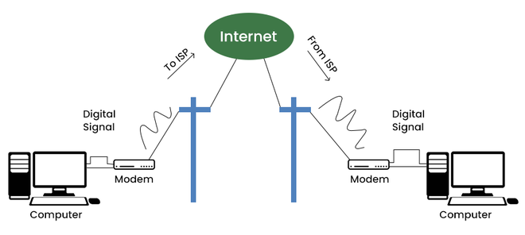

2. ISDN (Integrated Services Digital Network)

Definition (from "Data and Computer Communications" by William Stallings):  
"ISDN is a digital communication system that integrates voice, video, and data transmission over standard telephone lines, improving speed and reliability over traditional analog connections."

* + Benefits of ISDN Connection:
    - Faster than Dial-Up: ISDN offers higher data transfer rates compared to traditional dial-up, making it a better option for businesses and homes.
    - Supports Multiple Services: It can transmit voice, video, and data simultaneously, making it a versatile communication system.
    - More Reliable Connection: Unlike dial-up, ISDN establishes digital connections, reducing noise and improving signal clarity.
  + Drawbacks of ISDN Connection:
    - Expensive Infrastructure: ISDN requires specialized hardware and infrastructure upgrades, increasing installation and maintenance costs.
    - Limited Availability: ISDN services were not widely deployed in all regions, making accessibility an issue.
    - Eventually Replaced by Broadband and DSL: As newer and faster technologies emerged, ISDN became obsolete and is rarely used today.

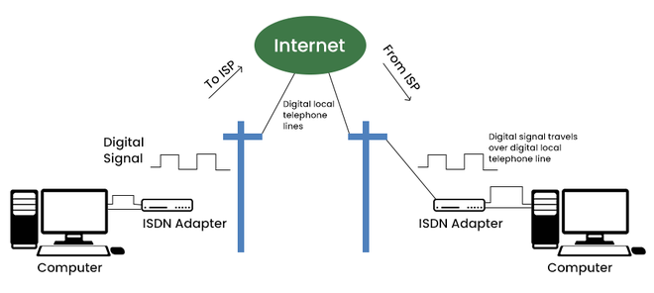

3. DSL (Digital Subscriber Line)

Definition (from "Data and Computer Communications" by William Stallings):  
"DSL is a broadband communication technology that transmits high-speed digital data over standard telephone lines, enabling faster internet access without disrupting voice calls."

* + Benefits of DSL Connection:
    - Higher Speeds than Dial-Up and ISDN: DSL significantly improves data transfer rates, supporting web browsing, video streaming, and online gaming.
    - Does Not Interfere with Phone Calls: Unlike dial-up, DSL allows users to access the internet while making phone calls simultaneously.
    - More Affordable than Fiber or Cable: DSL provides a cost-effective broadband solution for home and business users.
  + Drawbacks of DSL Connection:
    - Speed Depends on Distance: DSL performance degrades with distance from the provider’s central office, leading to slower speeds in rural areas.
    - Not as Fast as Fiber or Cable: While better than dial-up, DSL is outperformed by fibre and cable connections in terms of speed and reliability.
    - Requires a Phone Line: Although it does not interrupt phone calls, DSL still requires an active telephone line, limiting its flexibility.

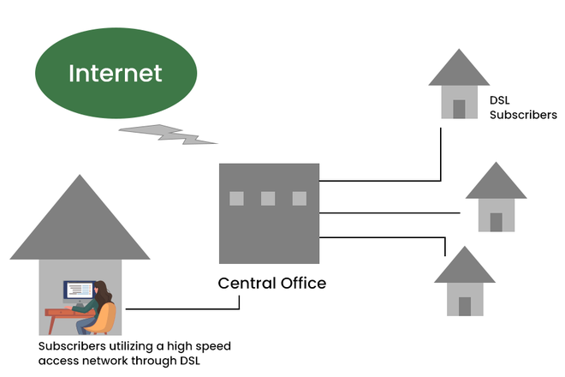

4. Broadband Connection

Definition (from "Data and Computer Communications" by William Stallings):  
"A broadband connection is a high-speed internet service that provides continuous access through technologies such as DSL, cable, fibre optics, or satellite, offering improved bandwidth and performance."

* + Benefits of Broadband Connection:
    - High-Speed Internet Access: Broadband connections offer significantly faster speeds than dial-up, enabling seamless streaming, gaming, video conferencing, and cloud computing.
    - Always-On Connection: Unlike dial-up, broadband remains constantly connected, allowing users to access the internet without having to reconnect each time.
    - Supports Multiple Devices: Broadband connections can handle multiple users and devices simultaneously, making them ideal for homes, businesses, and large organizations.
    - Reliable and Scalable: Broadband services provide stable and scalable connectivity, supporting modern digital needs such as remote work, e-learning, and IoT applications.
  + Drawbacks of Broadband Connection:
    - Higher Costs: Broadband services, particularly fibre-optic connections, can be expensive, requiring users to pay monthly fees for access.
    - Infrastructure Limitations: Not all areas, especially rural or remote locations, have broadband coverage, limiting accessibility for some populations.
    - Security Risks: Since broadband remains continuously connected, it is more vulnerable to cyber threats, requiring strong firewalls, encryption, and security protocols.
    - Network Congestion: In heavily populated areas, broadband speeds can slow down due to high traffic, affecting performance during peak hours.

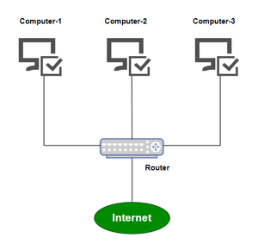

5. Cable Connection

Definition (from "Data and Computer Communications" by William Stallings):  
"Cable internet is a broadband technology that delivers high-speed internet access using the same coaxial cables that provide television service."

* + Benefits of Cable Connection:
    - Faster Speeds than DSL: Cable connections offer higher bandwidth, making them ideal for HD streaming and large file downloads.
    - Reliable Performance: Unlike DSL, cable internet is not affected by distance from the service provider.
    - No Need for a Telephone Line: Unlike dial-up or DSL, cable internet functions independently of telephone services.
  + Drawbacks of Cable Connection:
    - Shared Bandwidth: Cable connections suffer from speed reductions during peak hours, as bandwidth is shared among multiple users in a neighbourhood.
    - Higher Costs than DSL: Cable internet tends to be more expensive, especially for high-speed plans.

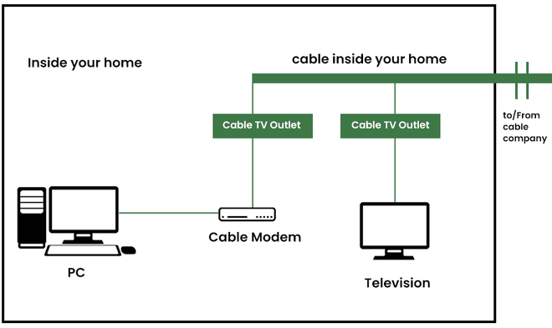

6. Satellite Connection

Definition (from "Data and Computer Communications" by William Stallings):  
"Satellite internet is a wireless broadband technology that provides internet access via geostationary or low-earth orbit satellites, enabling connectivity in remote areas."

* + Benefits of Satellite Connection:
    - Accessible in Remote Locations: Satellite internet is ideal for rural areas where cable and fibre infrastructure are unavailable.
    - Supports Global Coverage: It enables internet access in off-grid locations, including oceans and deserts.
  + Drawbacks of Satellite Connection:
    - High Latency: Due to the long distance between satellites and users, satellite internet suffers from high delays, making it unsuitable for gaming and video calls.
    - Expensive Equipment and Subscription Costs: Requires specialized dishes and receivers, increasing installation costs.

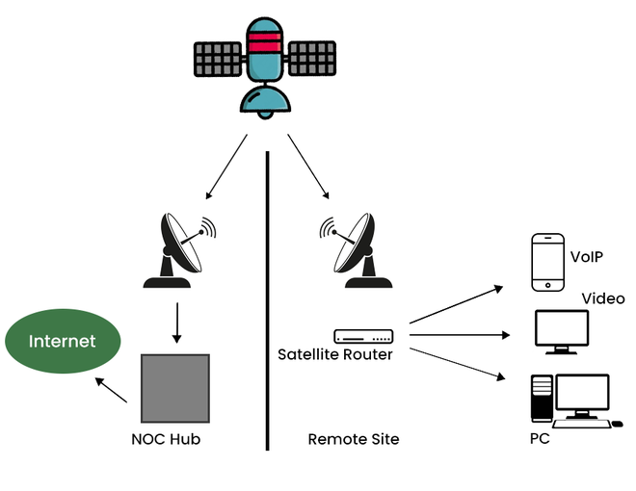

7. Wireless Connection

Definition (from "Data and Computer Communications" by William Stallings):  
"A wireless connection is a communication system where data transmission occurs over radio waves, infrared signals, or satellite links instead of physical cables, enabling flexible and mobile connectivity."

* + Benefits of Wireless Connection:
    - Greater Mobility and Convenience: Wireless connections allow users to move freely while staying connected to the network. This is essential for mobile devices such as laptops, smartphones, and tablets.
    - Easier and Cost-Effective Deployment: Unlike wired networks, wireless networks eliminate the need for physical cabling, reducing installation costs and making them easier to set up in homes, offices, and public areas.
    - Scalability and Flexibility: Wireless networks are easier to expand, as new devices can be connected without requiring additional wiring. Businesses can scale their network coverage without significant infrastructure changes.
    - Supports IoT and Smart Devices: Many modern technologies, such as smart home systems, wearable devices, and industrial automation, rely on wireless connectivity for seamless operation.
  + Drawbacks of Wireless Connection:
    - Signal Interference and Reliability Issues: Wireless networks are susceptible to interference from other electronic devices, walls, and physical obstacles. This can lead to unstable connections and slower speeds, especially in congested areas.
    - Lower Security Compared to Wired Networks: Wireless signals can be intercepted, making them more vulnerable to cyberattacks, unauthorized access, and data breaches. Encryption methods like WPA3 help, but risks still exist.
    - Limited Bandwidth and Speed: Wireless connections generally offer lower bandwidth compared to wired networks, especially when multiple devices are connected simultaneously. This can result in network congestion and reduced performance.
    - Power Dependency: Wireless routers, access points, and repeaters require constant power, meaning network failures can occur during power outages unless backup solutions are in place.

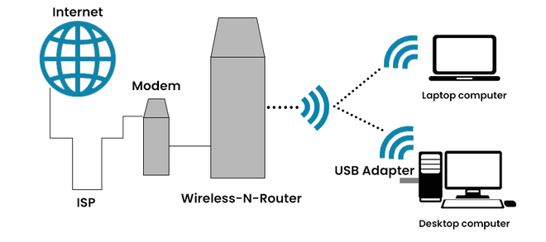

8. Cellular Connection

Definition (from "Data and Computer Communications" by William Stallings):  
"Cellular networks provide wireless internet access through mobile towers, enabling data connectivity for mobile devices over 3G, 4G, and 5G technologies."

* + Benefits of Cellular Connection:
    - Portable and Convenient: Supports mobile internet access anywhere within network coverage.
    - Fast Speeds with 5G: Newer cellular networks offer high-speed, low-latency internet comparable to broadband.
  + Drawbacks of Cellular Connection:
    - Data Caps: Many mobile providers enforce data limits.
    - Coverage Issues: Connectivity depends on network towers, making rural access unreliable.

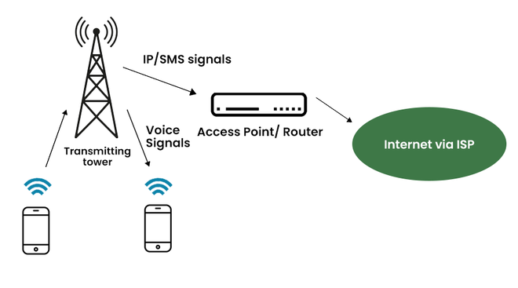

Que4) Write a short note on different ports like HDMI, VGA, Ethernet, C type, B type, USB, thunderbolt?

1. HDMI (High-Definition Multimedia Interface)

1.1 History

HDMI was introduced in 2003 by a group of major electronics companies, including Sony, Philips, Panasonic, and Toshiba. Before HDMI, VGA and DVI were commonly used for video transmission, but they had limitations—VGA was analog, and DVI only supported video, not audio. HDMI revolutionized the industry by combining high-definition video and high-quality audio into a single cable, simplifying home entertainment and computer displays.

1.2 Benefits

* + - Supports high-definition (HD) and ultra-high-definition (4K, 8K) video with crystal-clear quality.
    - Carries both audio and video, eliminating the need for multiple cables.
    - Supports multiple audio formats, including Dolby Atmos and DTS:X.
    - Found in a variety of devices, from TVs to gaming consoles, making it highly versatile.

1.3 Everyday Use Cases

* + - Connecting laptops to monitors or TVs for presentations and media streaming.
    - Gaming consoles like PlayStation and Xbox use HDMI to deliver high-quality visuals and surround sound.
    - Home theatre systems and soundbars rely on HDMI for superior audio transmission.

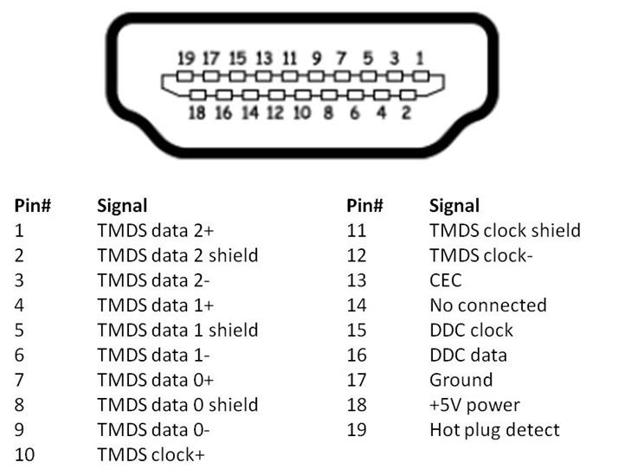

2. VGA (Video Graphics Array)

2.1 History

VGA was introduced by IBM in 1987 as a standard for computer monitors. It became widely popular for displaying graphics on CRT (cathode ray tube) monitors. VGA was an analog standard, meaning it relied on electrical signals that could degrade over long cable distances. As technology advanced, VGA was gradually replaced by digital alternatives like DVI, HDMI, and DisplayPort.

2.2 Benefits

* + - Widely supported in older monitors and projectors, making it useful for legacy systems.
    - Cost-effective and durable, as many older computers still have VGA ports.
    - Simple plug-and-play functionality without the need for additional drivers.

2.3 Everyday Use Cases

* + - Used in older projectors and monitors for connecting PCs in classrooms and offices.
    - Some industrial machines and legacy computing systems still rely on VGA connections.

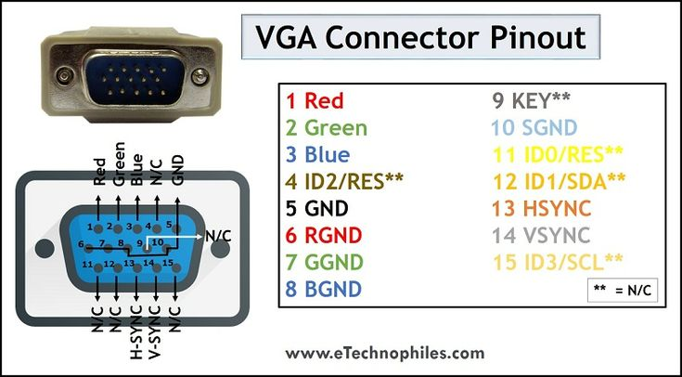

3. Ethernet Port (RJ-45)

3.1 History

Ethernet technology was developed in the 1970s by Xerox PARC, later standardized by IEEE as IEEE 802.3 in 1983. Before Ethernet, computers relied on slow and unreliable serial and parallel connections for networking. Ethernet allowed computers to communicate in a local network (LAN) efficiently, leading to the rise of modern networking and the internet as we know it today.

3.2 Benefits

* + - Stable and fast internet connection compared to Wi-Fi.
    - Lower latency, which is crucial for gaming and video conferencing.
    - Supports high-speed data transfer (up to 10 Gbps with modern Ethernet cables).

3.3 Everyday Use Cases

* + - Connecting desktop computers, gaming consoles, and smart TVs to the internet for a stable connection.
    - Used in business networks and data centres for high-speed communication.
    - Essential for security systems and surveillance cameras that require constant connectivity.

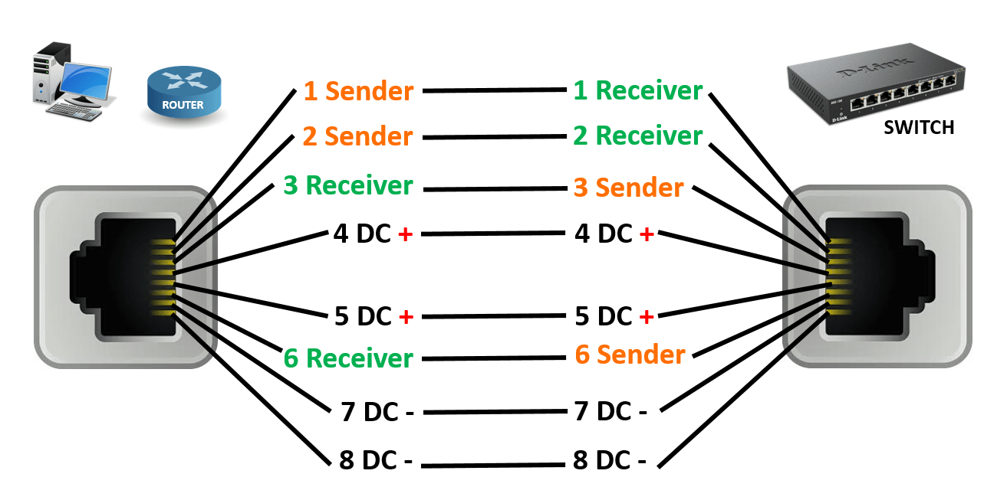

4. USB (Universal Serial Bus) – Type A, Type B, and Type C

4.1 USB Type-A

4.1.1 History

USB Type-A was introduced in 1996 as the first standardized USB connector. Before USB, devices used serial and parallel ports, which were slow and required separate drivers for different peripherals. USB Type-A revolutionized connectivity by offering a universal, plug-and-play solution for devices like keyboards, mice, and storage drives.

4.1.2 Benefits

* + - Wide Compatibility: Works with a variety of devices, including computers, gaming consoles, and televisions.
    - Reliable and Durable: A sturdy rectangular design that has lasted for decades.
    - Plug-and-Play Functionality: No need for additional drivers in most cases.

4.1.3 Everyday Use Cases

* + - Connecting external storage devices (USB flash drives, external hard drives).
    - Used in keyboards, mice, and gaming controllers.
    - Charging low-power devices like small gadgets and MP3 players.

4.2 USB Type-B

4.2.1 History

USB Type-B was introduced alongside USB Type-A in 1996. It was mainly designed for peripherals like printers and scanners, which needed a different connector shape. Type-B helped standardize communication between computers and external devices, eliminating the need for multiple proprietary cables.

4.2.2 Benefits

* + - Specialized for Larger Peripherals: Ideal for devices like printers, scanners, and industrial equipment.
    - Stable Connection: The design ensures a firm and secure connection with minimal risk of accidental disconnection.
    - Supports High-Speed Data Transfer: Newer versions (USB 3.0 Type-B) allow faster data transmission.

4.2.3 Everyday Use Cases

* + - Connecting printers, scanners, and industrial equipment to computers.
    - Used in some external hard drives and audio interfaces.
    - Medical and laboratory equipment rely on USB Type-B for stable data transfer.

4.3 USB Type-C

4.3.1 History

USB Type-C was introduced in 2014 to replace older USB types by offering a single, universal port for data transfer, charging, and video output. Unlike its predecessors, Type-C features a reversible design, solving the common frustration of inserting USB cables the wrong way. It quickly became the standard for modern devices, including smartphones, tablets, and laptops.

4.3.2 Benefits

* + - Reversible Design: No need to worry about plugging it in the wrong way.
    - High-Speed Data Transfer: Supports USB 3.1, USB 4.0, and Thunderbolt, with speeds up to 40 Gbps.
    - Power Delivery (PD): Can charge laptops, tablets, and phones with up to 100W power output.
    - Supports Video Output: Can replace HDMI and DisplayPort for connecting monitors and external displays.

4.3.3 Everyday Use Cases

* + - Charging smartphones, laptops, and tablets.
    - Used for high-speed data transfer in external SSDs and hard drives.
    - Connecting to external monitors and docking stations for dual-screen setups.
    - Replaces older USB versions in modern devices like MacBooks, gaming consoles, and flagship Android phones.

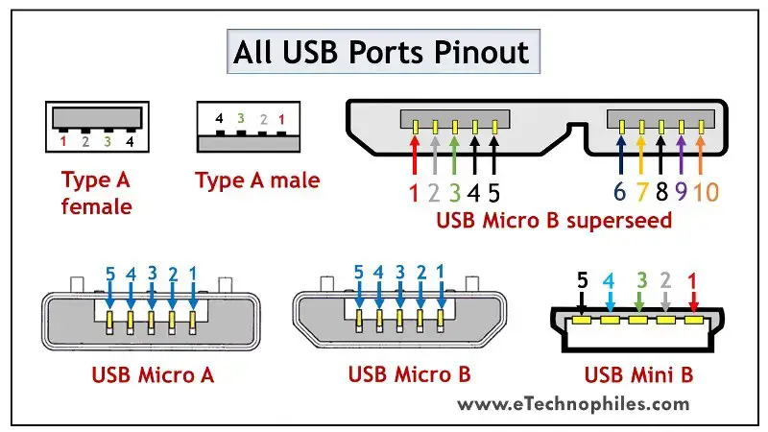

5. Thunderbolt Port

5.1 History

Thunderbolt was co-developed by Intel and Apple and introduced in 2011 as a high-speed data and video connection port. The early versions were limited to Apple devices, but Thunderbolt 3 and Thunderbolt 4 became widely used in high-end laptops and monitors.

5.2 Benefits

* + - Extremely fast data transfer speeds (up to 40 Gbps in Thunderbolt 3 & 4).
    - Supports multiple functions, including data transfer, power delivery, and video output, using a single port.
    - Backward compatible with USB-C devices.

5.3 Everyday Use Cases

* + - Used in MacBooks and high-end Windows laptops for connecting external storage, monitors, and docking stations.
    - Video production professionals use Thunderbolt for connecting 4K/8K displays and external GPUs.

